Testing Report

Tally Portal



Contents

1 Stock Module 2

Stock Module Test Summary Report 2

1.1 Final Product Stock Statement 2

1.2 Godown Stock Transfer 3

1.3 Godown Stock Summary 3

1.4 Stock Details 4

1.5 Lead Time Report 4

1.6 Negative Batch Report 5

2 Purchase Module 6

Purchase Module Test Summary Report 6

2.1 Pending Purchase Order 6

2.2 Pending Purchase Bill 7

2.3 Vendor Outstanding 7

2.4 Negative Stock Report 8

3 Sales Module 9

Sales Module Test Summary Report 9

3.1 Pending Sales Bill 9

4 Accounts Module 10

Accounts Module Test Summary Report 10

4.1 Debit Credit Note Register 10

4.2 Journal Register 11

4.3 Cash Book 11

4.4 Ledger Report 12

4.5 Cost Center Report 12

4.6 Negative Ledger Report 13

4.7 Exception Report 14

# Stock Module

## Stock Module Test Summary Report

|  |  |  |  |  |  |  |
| --- | --- | --- | --- | --- | --- | --- |
| **#** | **Report Name** | **View Data** | **Report Filter** | **Export in Excel** | **Released On** | **Test Reply by Mendine** |
| 1 | **Final Product Stock Statement** | **Yes** | **Yes** | **Yes** | **25-Jul-20** |  |
| 2 | **Godown Stock Transfer** | **Yes** | **Yes** | **Yes** | **26-Jan-21** |  |
| 3 | **Godown Stock Summary** | **Yes** | **Yes** | **Yes** | **26-Jan-21** |  |
| 4 | **Stock Details** | **Yes** | **Yes** | **Yes** | **26-Jan-21** |  |
| 5 | **Lead Time Report** | **Yes** | **Yes** | **Yes** | **25-Jul-20** |  |
| 6 | **Negative Batch Report** | **Yes** | **Yes** | **Yes** | **17-Apr-21** |  |

## Final Product Stock Statement

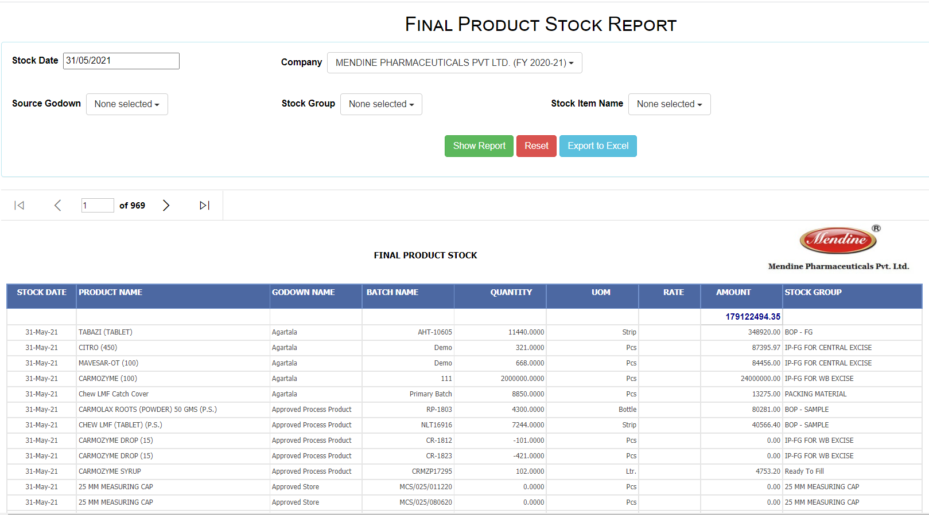

## Godown Stock Transfer

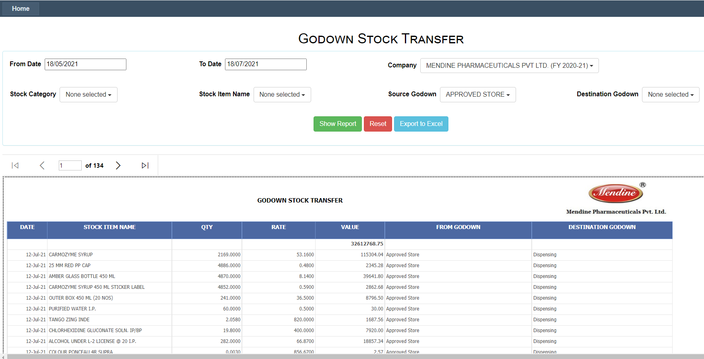

## Godown Stock Summary

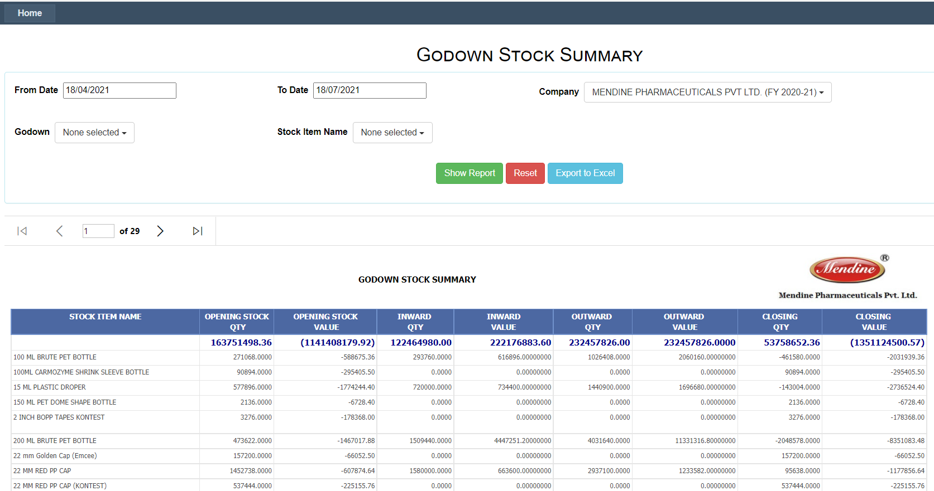

## Stock Details

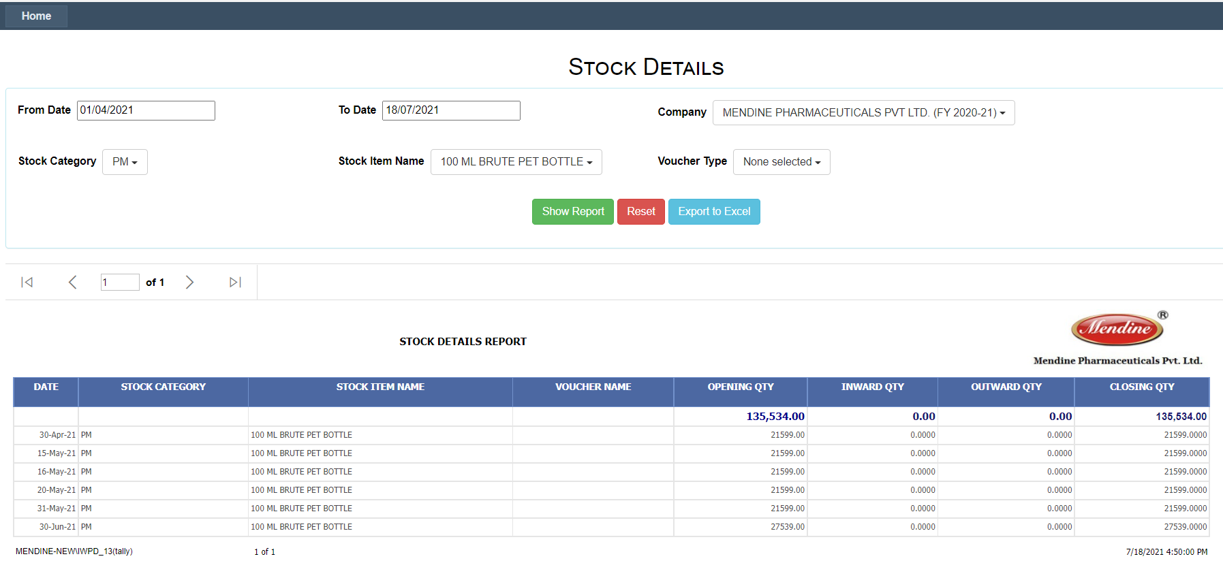

## Lead Time Report

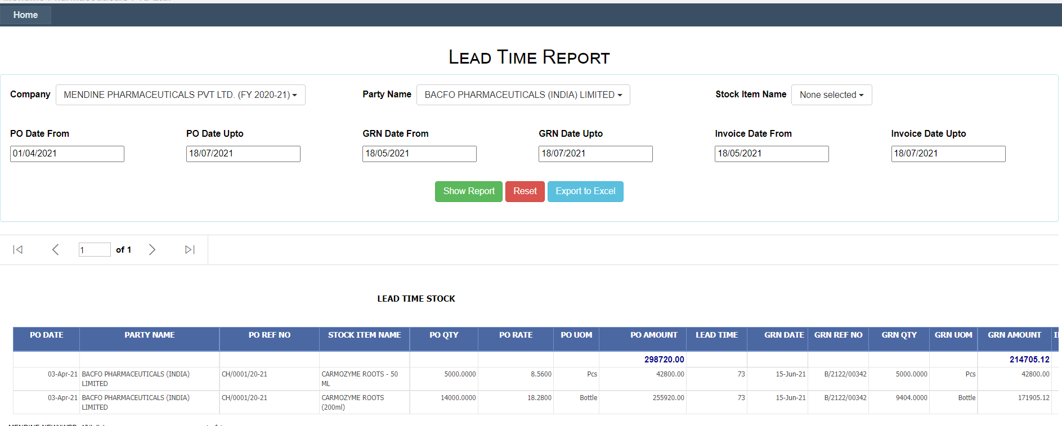

## Negative Batch Report

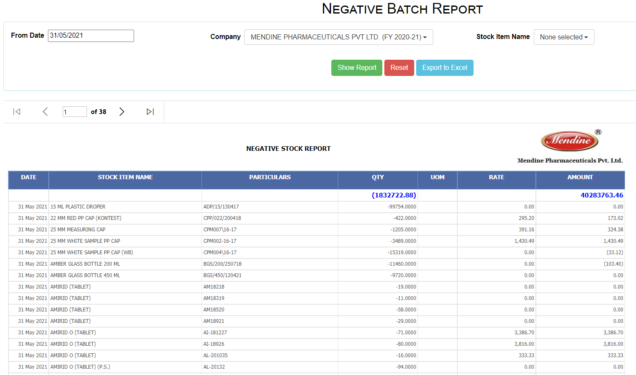

# Purchase Module

## Purchase Module Test Summary Report

|  |  |  |  |  |  |  |
| --- | --- | --- | --- | --- | --- | --- |
| **#** | **Report Name** | **View Data** | **Report Filter** | **Export in Excel** | **Released On** | **Test Reply by Mendine** |
| 1 | **Pending Purchase Order** | **Yes** | **Yes** | **Yes** | **20-Nov-20** | **Yes** |
| 2 | **Pending Purchase Bill** | **Yes** | **Yes** | **Yes** | **26-Jan-21** | **Yes** |
| 3 | **Vendor Outstanding** | **Yes** | **Yes** | **Yes** | **26-Jan-21** | **Yes** |
| 4 | **Negative Stock Report** | **Yes** | **Yes** | **Yes** | **26-Jan-21** |  |

## Pending Purchase Order

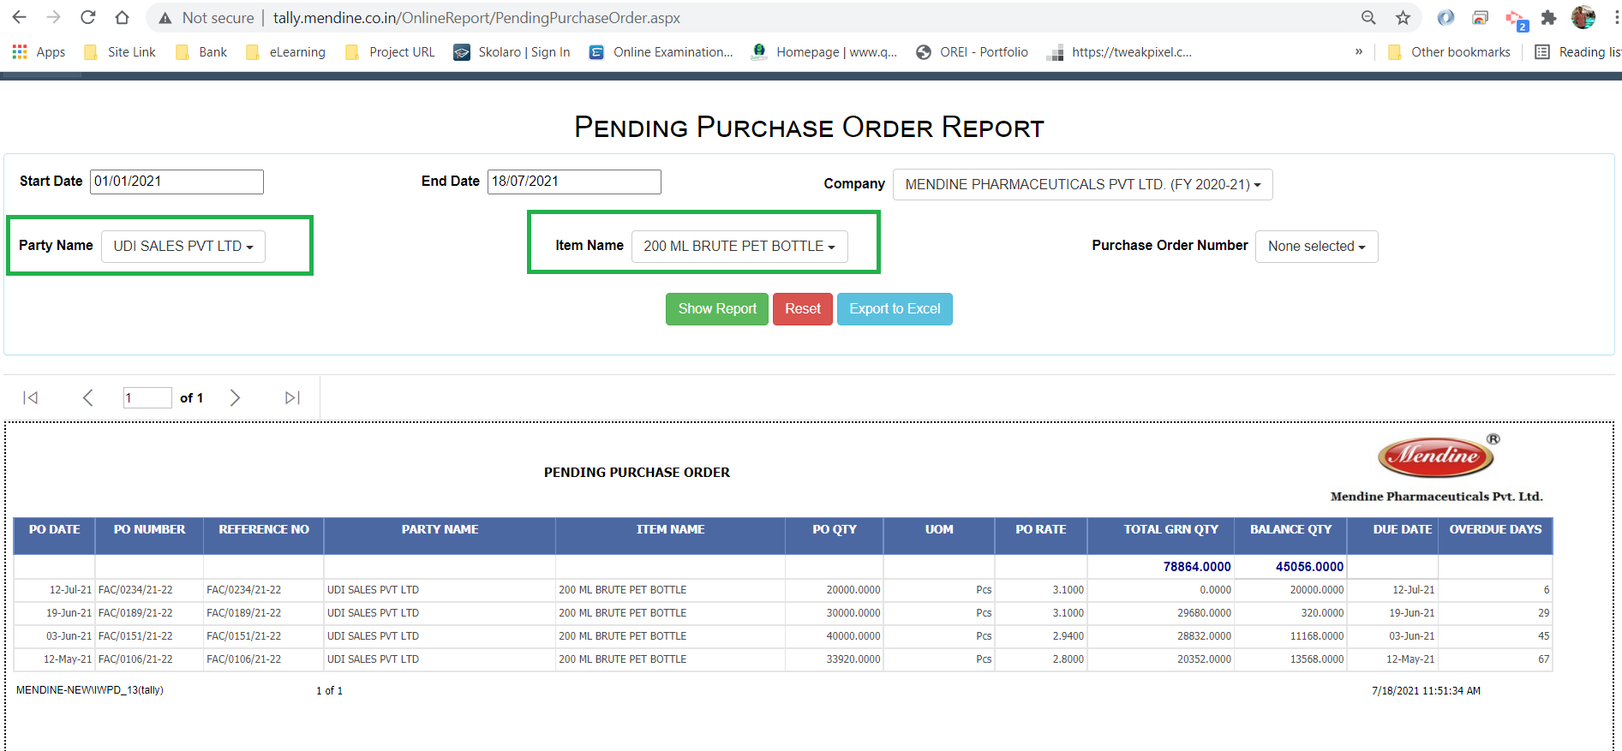

## Pending Purchase Bill

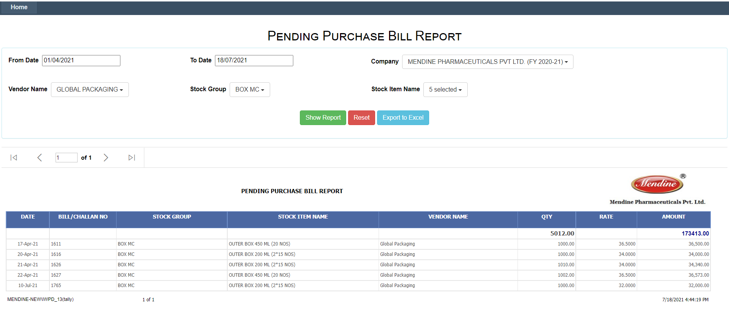

## Vendor Outstanding

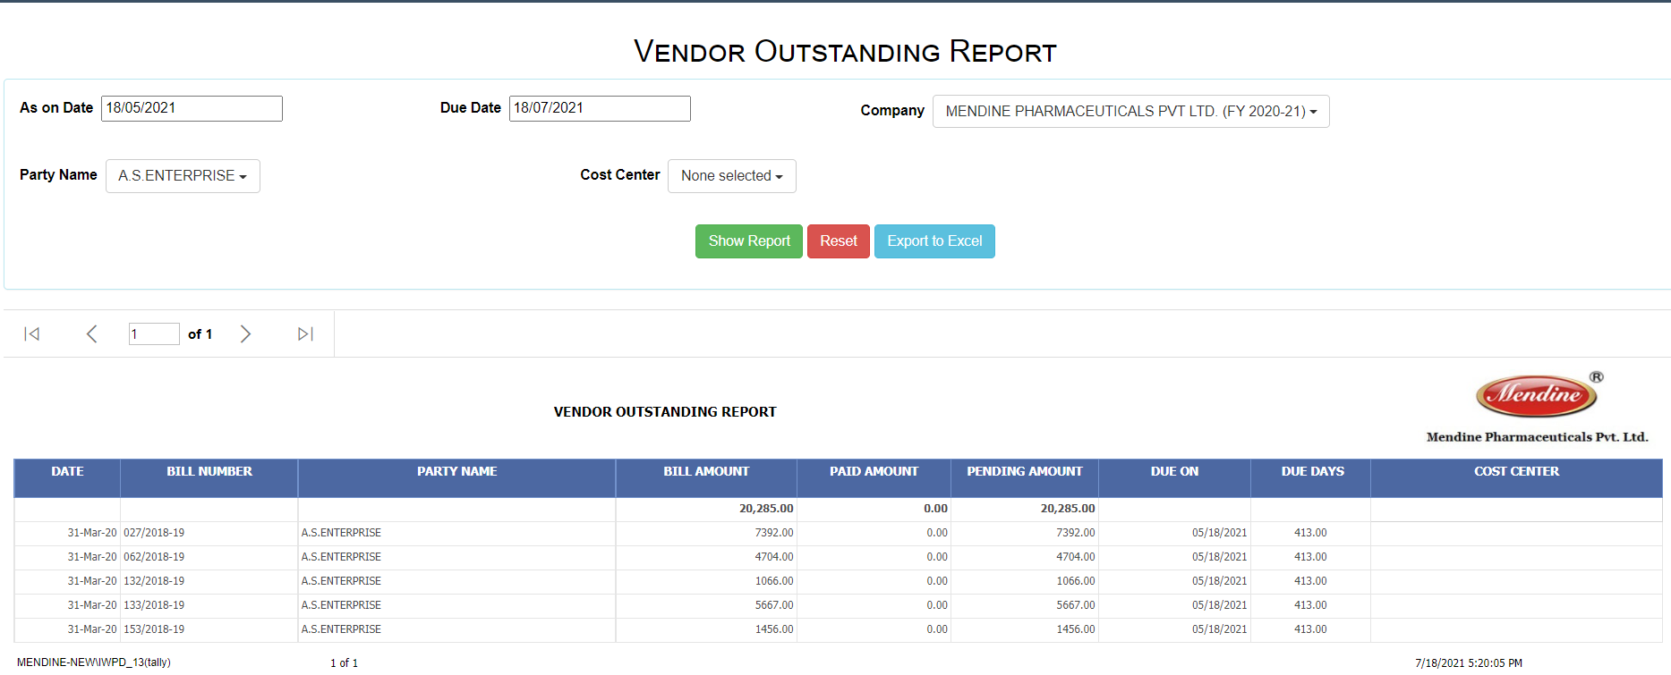

## Negative Stock Report

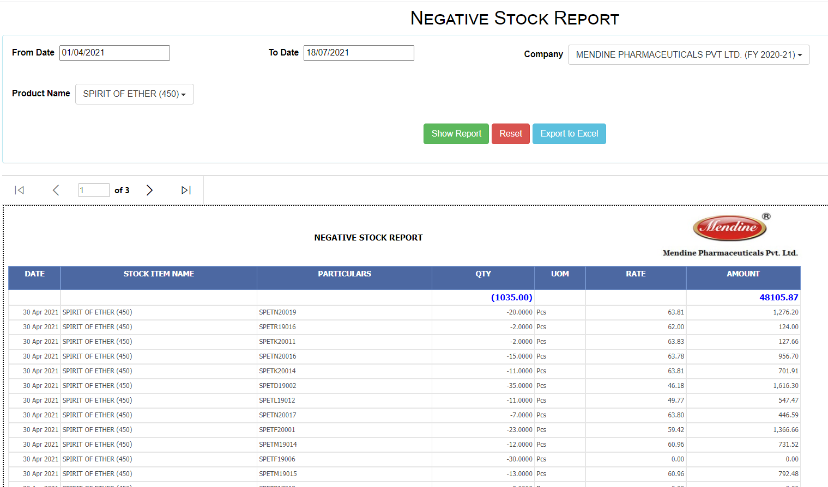

# Sales Module

## Sales Module Test Summary Report

|  |  |  |  |  |  |  |
| --- | --- | --- | --- | --- | --- | --- |
| **#** | **Report Name** | **View Data** | **Report Filter** | **Export in Excel** | **Released On** | **Test Reply by Mendine** |
| 1 | **Pending Sales Bill** | **Yes** | **Yes** | **Yes** | **26-Jan-21** | **Yes** |

## Pending Sales Bill

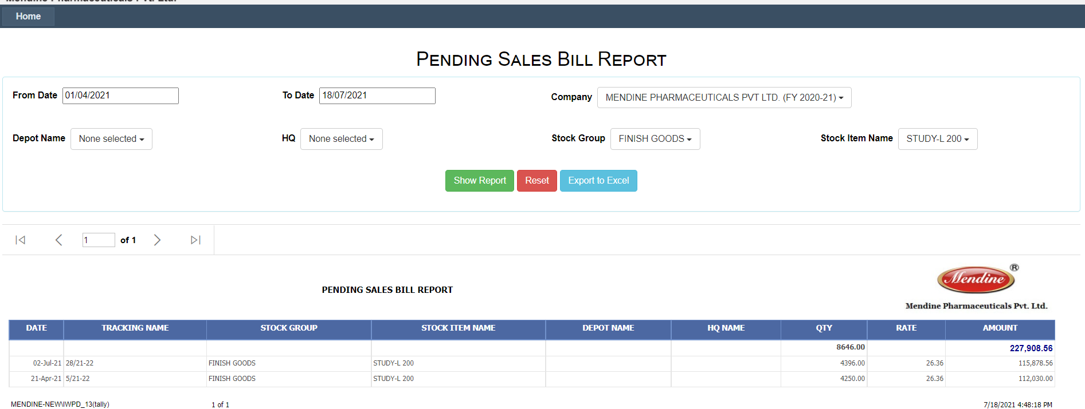

# Accounts Module

## Accounts Module Test Summary Report

|  |  |  |  |  |  |  |
| --- | --- | --- | --- | --- | --- | --- |
| **Serial** | **Report Name** | **View Data** | **Report Filter** | **Export in Excel** | **Released On** | **Tested by Mendine** |
| 1 | **Debit Credit Note Register** | Yes | Yes | Yes | 26-Jan-21 | Yes |
| 2 | **Journal Register** | Yes | Yes (Led) | Yes | 26-Jan-21 | Yes |
| 3 | **Ledger Report** | Yes | Yes | Yes | 9-Apr-21 |  |
| 4 | **Cash Book** | Yes | Yes | Yes | 24-Apr-21 | Yes |
| 5 | **Cost Center Report** | Yes | Yes | Yes | 9-Apr-21 |  |
| 6 | **Negative Ledger Report** | Yes | Yes | Yes | 26-Jan-21 |  |
| 7 | **Exception Report** | Yes | Yes | Yes | 7-Jun-21 |  |

## Debit Credit Note Register

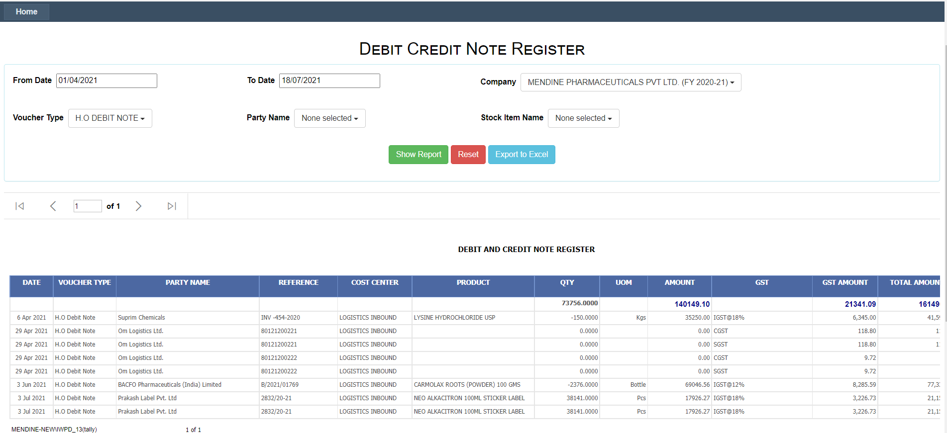

## Journal Register

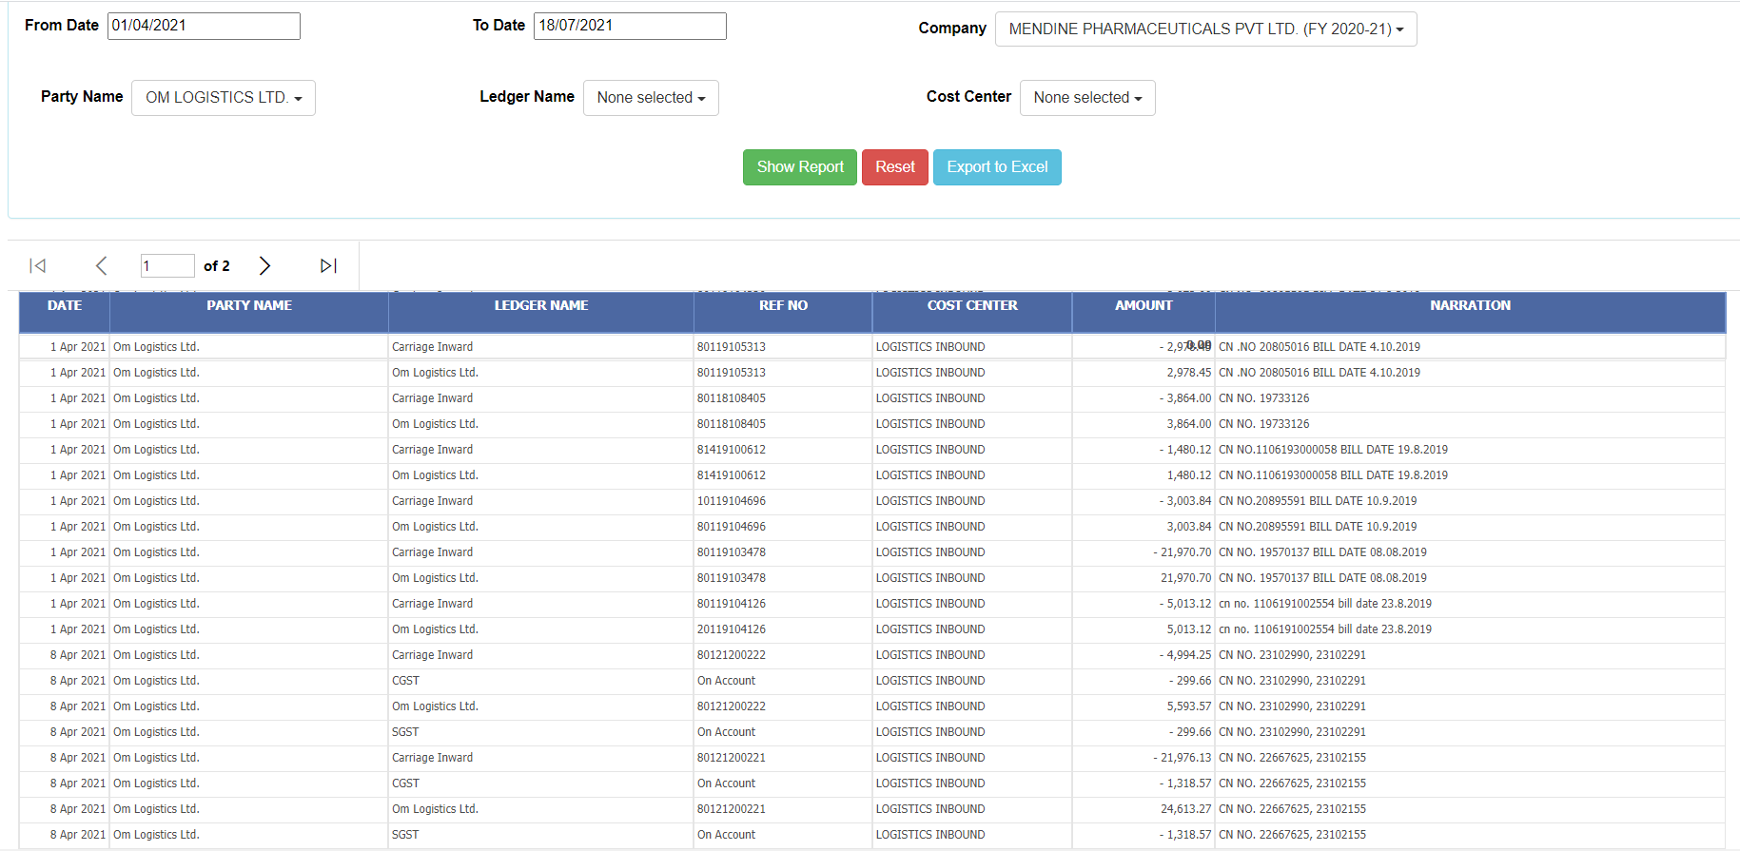

## Cash Book

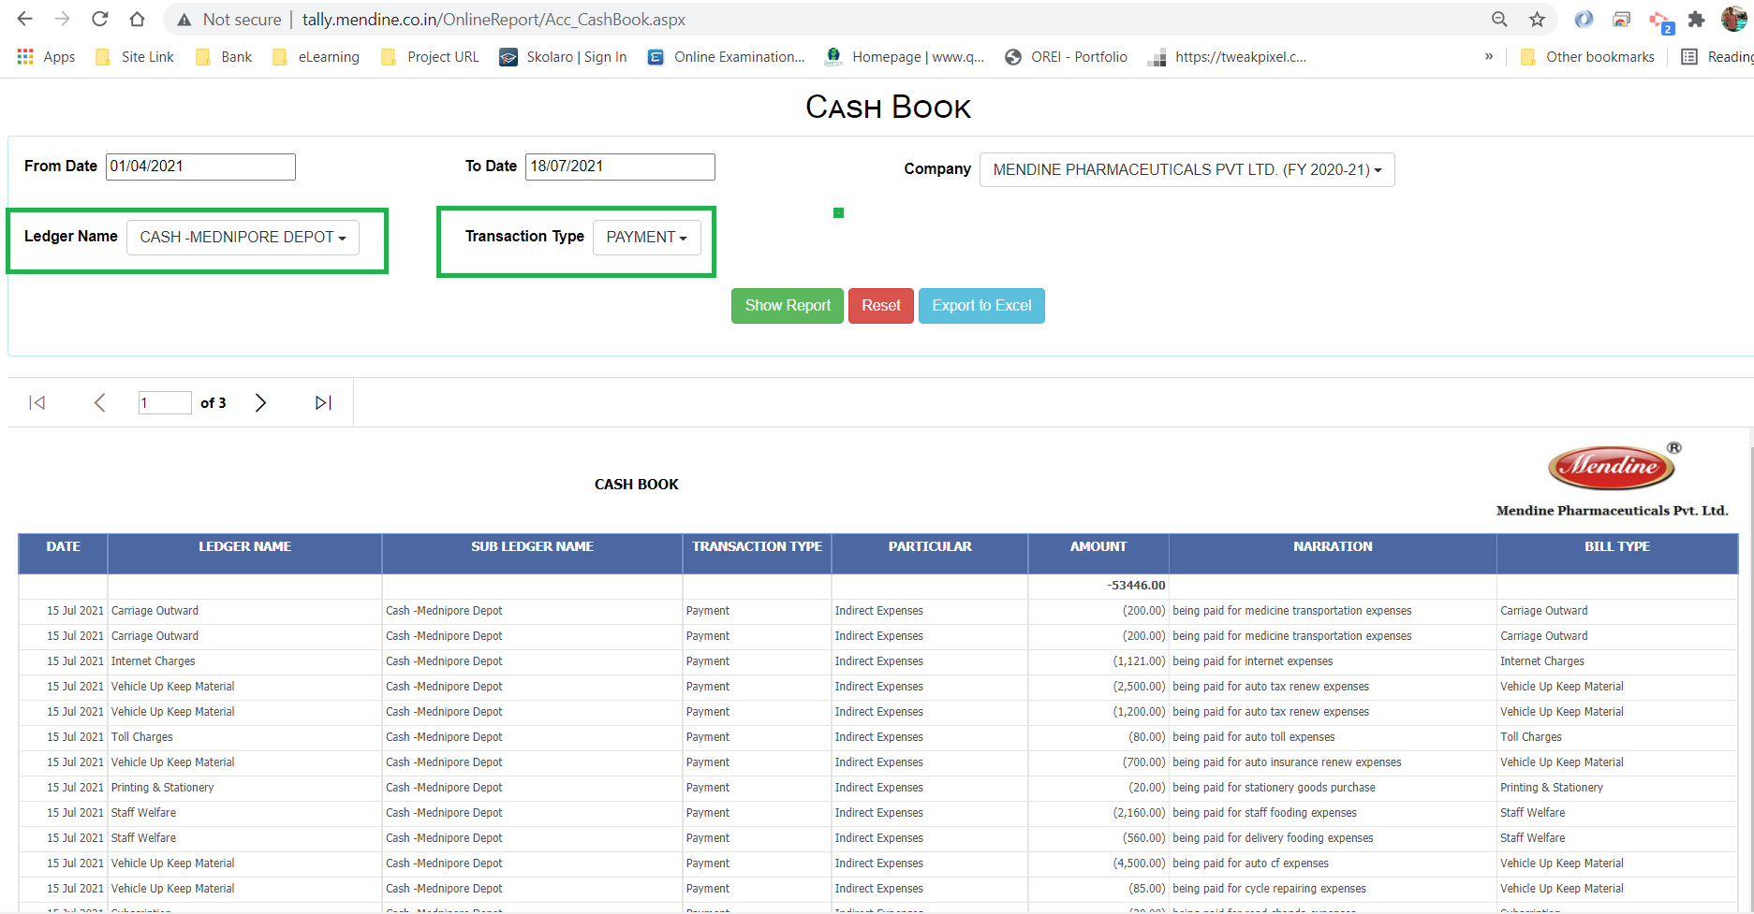

## Ledger Report

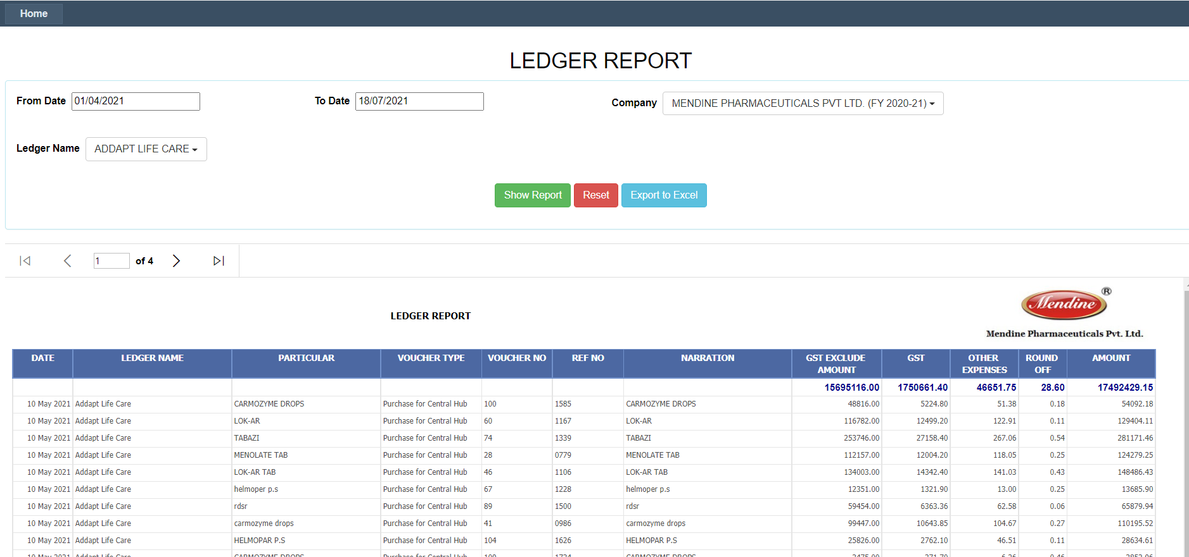

## Cost Center Report

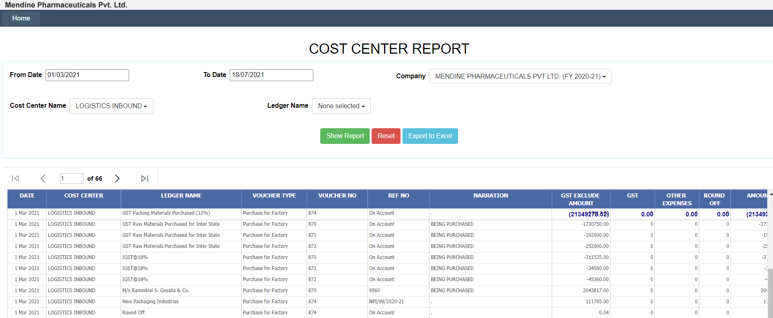

## Negative Ledger Report

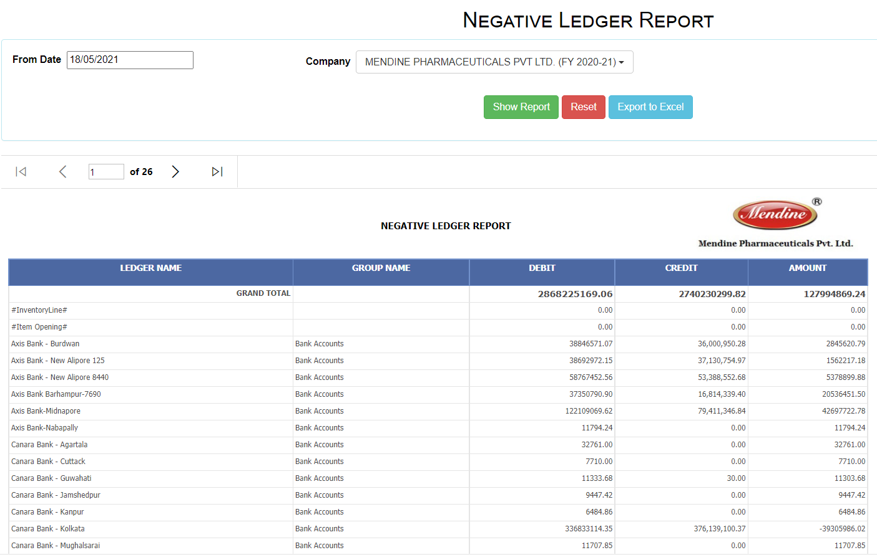

## Exception Report

